*HIVE COMMANDS*

create database dna;

show databases;

use dna;

create table info(name varchar(50), AGATC int, AATG int, TATC int);

load data local inpath '/home/hadoop/Documents/small.csv' into table info;

insert into info values('Alice',2,8,3);

insert into info values('Bob',4,1,5);

select * from info;

create view repeat as select name from info where AATG=2;

select * from repeat;

drop view repeat;

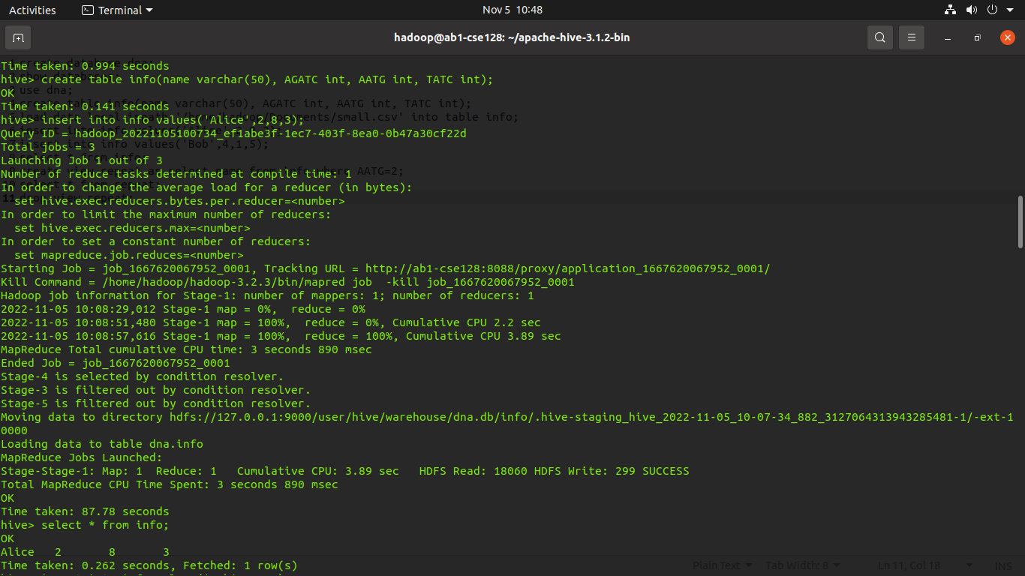

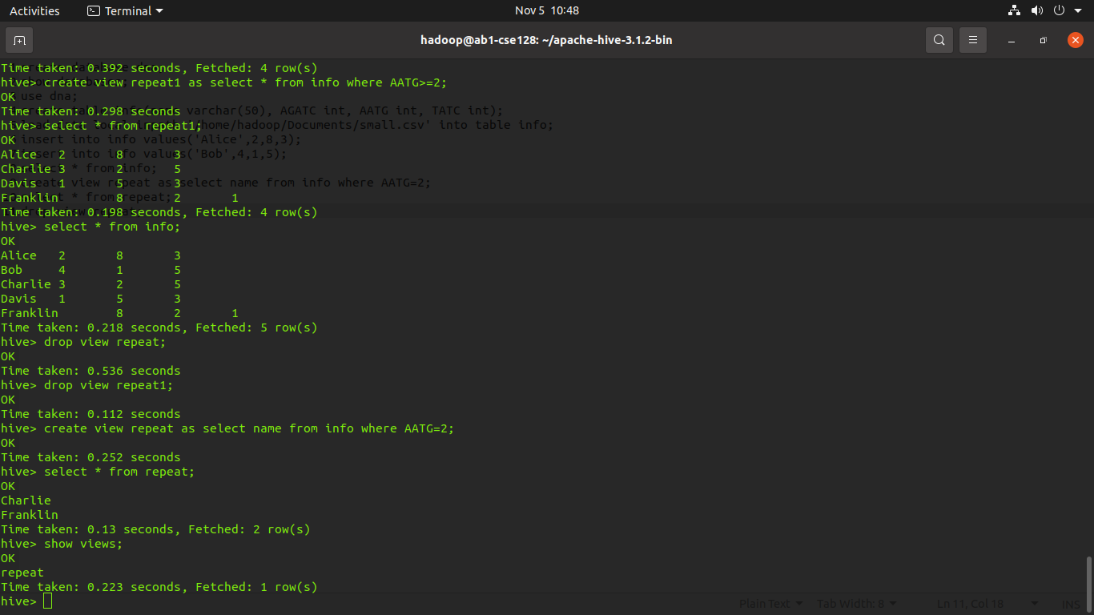

name AGATC AATG TATC  
Alice 2 8 3  
Bob 4 1 5  
Charlie 3 2 5

Sequencing DNA means determining the order of the four chemical building blocks - called "bases" - that make up the DNA molecule. The sequence tells scientists the kind of genetic information that is carried in a particular DNA segment.

*PIG COMMANDS*

hadoop fs -mkdir hdfs://localhost:9000/dna

hadoop fs -put '/home/hadoop/Downloads/small.csv' /dna

pig -x local

short_dna = LOAD 'hdfs://localhost:9000/dna/small.csv' USING PigStorage(',') as (name:chararray,AGATC:int,AATG:int,TATC:int);

dump short_dna;

explain short_dna;

illustrate short_dna;

filter_data = FILTER short_dna BY name=='Alice';

dump filter_data;

order_by_data = ORDER short_dna BY AATG DESC;

dump order_by_data;

